

**Provisioning Template to Show Virtual Server Protocol**

**User Guide**

|  |  |  |
| --- | --- | --- |
| **Version** | **Remarks** | **Date** |
| **1.0** | **Provisioning Template User Guide for Show Virtual Server Protocol.** | **30/01/2017** |
| **2.0** | **Updated document with installation of the template.** | **14/02/2017** |
|  |  |  |
|  |  |  |

## Installation of the Template and Helper Script

1. Login to AppViewX.
2. On the left navigation menu, select ***Provisioning***; and click ***Template.***
3. On the upper right portion of the screen click on the  Import button.
4. The following screen will appear. 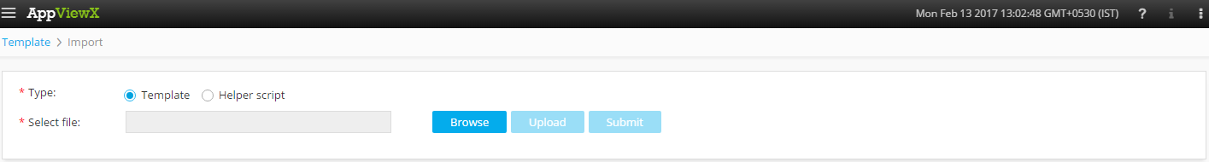
5. Please Select Template/Helper Script.  
   If Template is chosen,
   1. Click on *Browse* and select the Zip File of the template which has to be installed/imported and click open.
   2. Click on upload to import the Zip file and display the templates present in the zip file.
   3. Click on submit to deploy the templates into the AppViewX Environment.

If Helper Script is chosen,

1. Click on *Browse* and select the Zip File of the Helper script which has to be installed/imported and click open.
2. Click on upload to import the Zip file and display the Helper Scripts present in the zip file.
3. Click on submit to deploy the Helper Scripts into the AppViewX Environment.

## SHOW VIRTUAL SERVER PROTOCOL

1. Login to AppViewX.
2. On the left navigation menu, select ***Provisioning***; and click ***Request.***
3. On the upper right portion of the screen, click the  ***Create*** button.
4. Select the provisioning template name from the list –‘**VIP_Status_Protocol**’.

**Note:** *If no template is available, this indicates that the user role does not have permission to the requesting template.*

1. Enter the provisioning request description – ‘*VIP_Status_Protocol*’.
2. Add a default Request scenario name relevant to the template. ***E.g***.: Show Status Protocol.
3. Please Enter email id, to which the status file has to be sent.
4. Click on ‘***Get Device List***’ button to fetch the available list of devices in the inventory.
5. In the **Device** field, list of devices are populated. Please select the device for which the status profile of the virtual server profile status has to be retrieved.
6. Please select the protocol associated to the Device for which the Virtual server Profile status has to be retrieved.
7. Click on ‘***Get VIP Status***’ button to fetch the available list of devices in the inventory with their respective profile status.
8. Select a VIP from the selected device and device protocol whose profile status has to be displayed from the list of VIPs associated to the particular device and its protcol.
9. The fields which will be displayed after selecting a particular VIP associated to the device and its protocol are,
   1. Device – The device which associated with the VIP will be displayed.
   2. VIP Name – The VIP which is selected will displayed in the Field.
   3. Profile – The profile of the VIP will be displayed in this field.
   4. Profile Type – The Profile Type of the VIP will be displayed (Client/Server).
   5. Cipher – The Cipher Value of the VIP will be displayed.
10. Please enter a relevant File Name with *'.csv'* extension, an email with the Profile status of the VIP will be sent with the entered file name to the E-mail Address entered in the E-mail Field.
11. Click on *Submit* to generate work order(s) for the provisioning request.